**RFC-LFP002_v2**

**Suggested problem**  
The inputs SALW, OILAPI, GOR, SGG_O, and SGG_G have currently Location = Interval in 2018_lfp_fluidparameters.lls as shown in Figure 1.

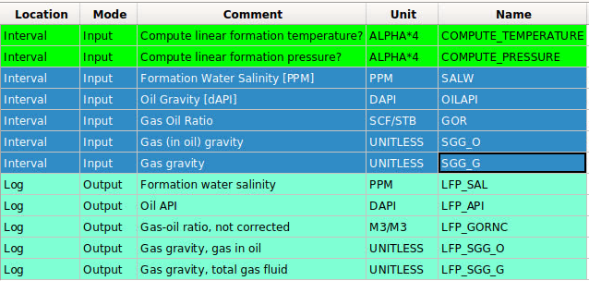  
Figure 1. Interval inputs for SALW, OILAPI, GOR, SGG_O, and SGG_G.

**Suggested solution**

Change the Location from Interval to Log for SALW, OILAPI, GOR, SGG_O, and SGG_G.

**Spelling mistake**

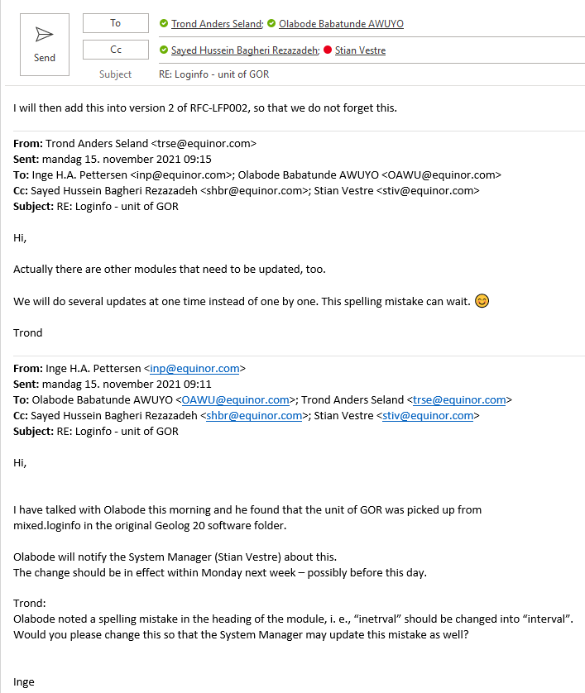

**Reference**

N/A